**Software Testing Module 4(selenium IDE)**

**Q-1** **What is Automation Testing?**

**Ans**:-

It’s a technique where the Tester writes scripts independently and uses suitable Software or Automation tools test the software. It is an Automation Process of a Manual Process. It allows for executing repetitive tasks without the intervention of a Manual Tester.

* It is used to automate the testing tasks that are difficult to perform manually.
* Automation tests can be run at any time of the day as they use scripted sequences to examine the software.
* Automation tests can also enter test data compare the expected result with the actual result and generate detailed test reports.
* The goal of automation tests is to reduce the number of test cases to be executed manually but not to eliminate manual testing.
* It is possible to record the test suit and replay it when required.



**Software Testing Module 4(selenium IDE)**

**Q-2 Which are the browsers supported by Selenium IDE?**

**Ans:-**

Selenium IDE (Integrated Development Environment) is a browser extension used for automating web applications. Currently browser supported are as bellow,

* Firefox
* Chrome
* Edge
* Safari

**Q-3** **What are the benefits of Automation Testing?**

**Software Testing Module 4(selenium IDE)**

**Ans:-**

* **Simplifies Test Case Execution**: Automation testing can be left virtually unattended and thus it allows monitoring of the results at the end of the process. Thus, simplifying the overall test execution and increasing the efficiency of the application.
* **Improves Reliability of Tests:** Automation testing ensures that there is equal focus on all the areas of the testing, thus ensuring the best quality end product.
* **Increases amount of test coverage:** Using automation testing, more test cases can be created and executed for the application under test. Thus, resulting in higher test coverage and the detection of more bugs. This allows for the testing of more complex applications and more features can be tested.
* **Minimizing Human Interaction**: In automation testing, everything is automated from test case creationto execution thus there are no changes for human error due to neglect. This reduces the necessity for fixing glitches in the post-release phase.
* **Saves Time and Money**: The initial investment for automation testing is on the higher side but it is cost-efficient and time-efficient in the long run. This is due to the reduction in the amount of time required for test case creation and execution which contributes to the high quality of work.
* **Earlier detection of defects**:  Automation testing documents the defects, thus making it easier for the development team to fix the defect and give a faster output. The earlier the defect is identified, the easier and more cost-efficient it is to fix the defects.

**Software Testing Module 4(selenium IDE)**

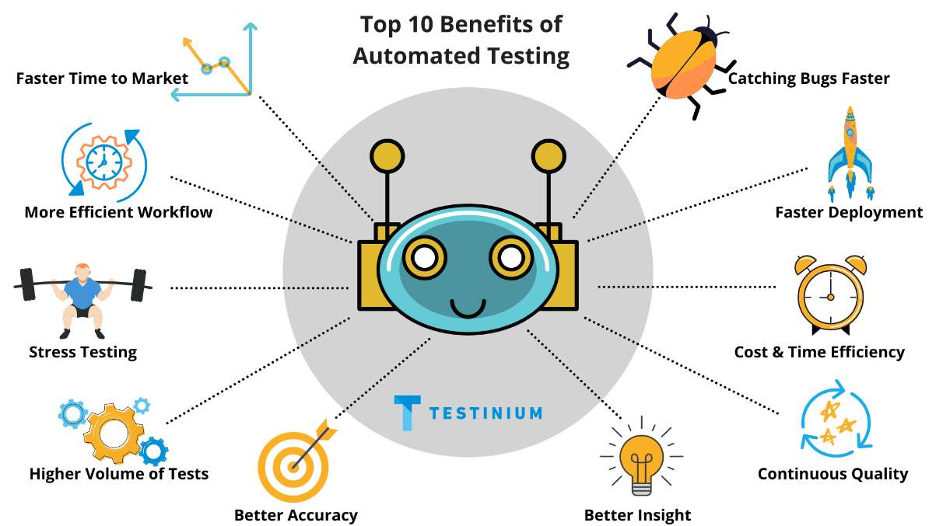

**Q-4** **What are the advantages of Selenium?**

**Ans**:-

* **Cross-Browser Compatibility:** Selenium supports multiple browsers like Chrome, Firefox, Safari, and Internet Explorer, making it easier to test web applications on different platforms.
* **Platform Independence:** Selenium is a cross-platform tool, which means it can be used on different operating systems like Windows, Linux, and macOS.

**Software Testing Module 4(selenium IDE)**

* **Support for Multiple Programming Languages:** Selenium supports multiple programming languages, including Java, C#, Python, Ruby, and others. This allows developers and testers to choose the language they are most comfortable with.
* **Large Community and Resources:** Selenium has a large and active community. This means there is a wealth of documentation, tutorials, and forums available, making it easier for users to find help and solutions to common problems.
* **Integration with Other Tools:** Selenium can be easily integrated with other tools and frameworks, such as TestNG, JUnit, Maven, and Jenkins, enhancing its capabilities and making it suitable for various testing needs.
* **Flexibility and Extensibility:** Selenium can be extended for various functionalities through its APIs, making it adaptable to different testing scenarios.
* **Support for Parallel Execution:** Selenium allows for the parallel execution of test scripts, which can significantly reduce the overall test execution time.

**Software Testing Module 4(selenium IDE)**

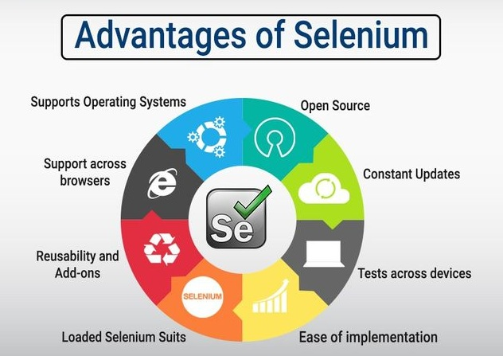

**Q-5 Why Tester should opt for Selenium and not QTP?**

**Ans:-**

Testers might opt for Selenium over QTP/UFT for several reasons:

* **Cost-effectiveness:** Selenium is free and open-source.
* **Flexibility**: Supports multiple programming languages and integrates with various tools.
* **Broad compatibility**: Offers extensive cross-browser and cross-platform testing.
* **Community support**: Benefits from a large and active user community.

**Software Testing Module 4(selenium IDE)**

However, the choice between Selenium and QTP/UFT will ultimately depend on the specific needs of the project, budget constraints, and the technical skills of the testing team. Both tools have their strengths and are suited for different testing environments and requirements.